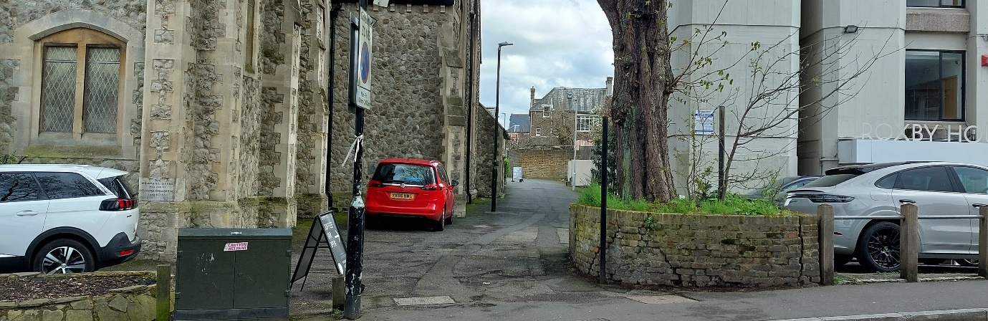

Dates: Wednesday 24 April, 29 May and 26th June 2024
Time: 10am to 12noon
New Venue: The Coffee Bar at New Community Church, 24 Station Rd, Sidcup, DA15 7DU

Bexley NAS parents and carers are warmly invited to join members of the Bexley NAS team for a coffee and chat. Come along and meet some of the Bexley NAS Committee, get to know other parent/carers who are members and take some time for you.

This coffee morning is for Bexley NAS Parents/Carers.

Our new venue for the next 3 months is The Coffee Bar and it can be accessed from Station Road or Hatherley Road. The photo is from Station Road. You walk down the side of the church and there is a Coffee Bar sign at the entrance.

Sidcup High Street is served by several buses. The nearest pay car parks are under the Morrisons car park and in Grassington Road (opposite Walnuts). Free parking is available on Victoria Road and Hatherley Road before 1pm – please check signage.

Please contact the branch on 07826950496 if you have any questions about the coffee morning.

If you are planning to join us, please let us know:
- Go to Activities - Bexley NAS and complete the request form.
- Please ensure you provide information for all those attending.

If you find you are able to come on the day, we’d love to see you.

Looking forward to buying members a cuppa.

